Fundamental Study on Tactile Cognition through

Visually impaired Tactile feedback Tactile memory

【Main Content】:

The paper studies the distinguishing accuracy and storage ability of visually impaired people for tactile information.

【Experiments】：

**Aparatus:** Tablet device MEDIAS TAB UL N-08D from NEC shown on Fig.1 was used to survey haptic differentiation from touch-screens with haptic feedback function. This device is the ﬁrst commercial machine that used HD Reverb software from Immersion, and by combining with Immersion’s TouchSense 5000 software [12], has the functionality to replicate sensitive haptic sensation with high degree of accuracy.

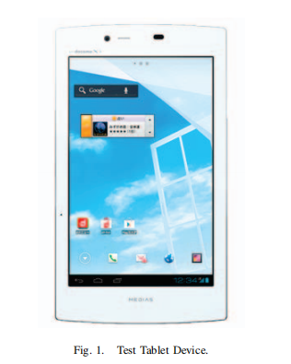 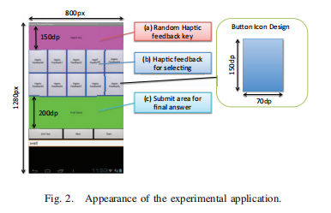

(The area (a) of Fig.2 shows the area where random virtual haptic sensations are presented. Area (b) is the ten haptic sensation choices set out upon icons on pre-determined locations. Area (c) is the button for making the ﬁnal submission, after judging what was touched last in (b) is the same as what was presented in (a).)

**Procedure：**

step1- 10 times exercises

Step2- 30 tactile sensation matching tests, and record in the database

(There is no gap between the two steps above)

**Results:**

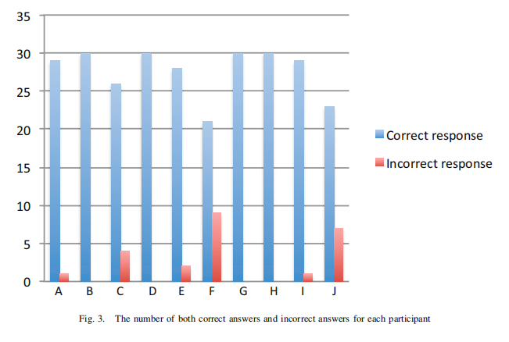 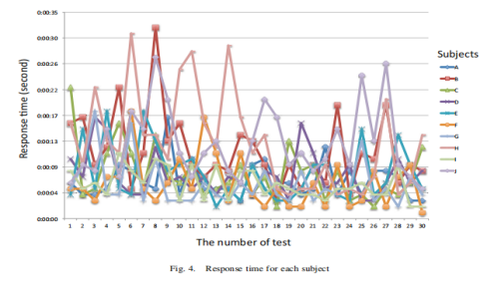

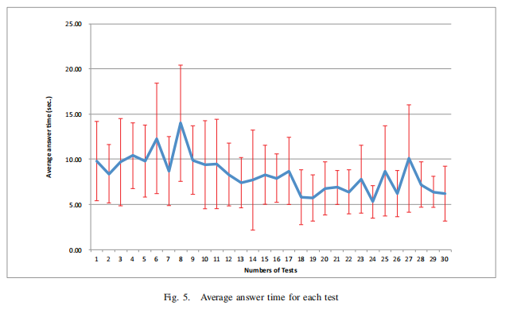 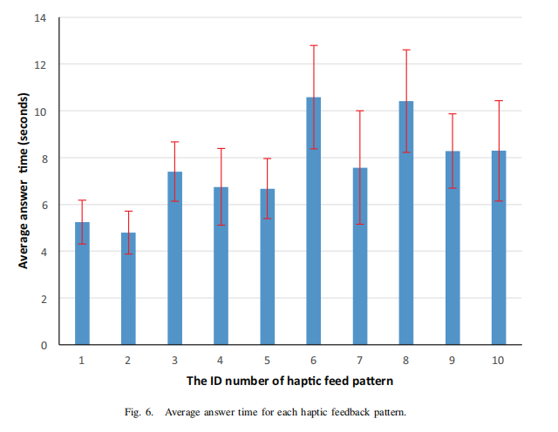

Although volunteers have some differences in response time, they are only about 3 to 15 seconds, and as the test is repeated, the time required to answer becomes shorter. The interesting fact is that the time required for answering gradually decreases from the 10th time and stabilizes between 15 and 30 times. This may mean that the tactile sensation assigned to the selection icon is partially or fully memorized, and it becomes easier to select the same sensation as the tactile sensation shown in the test.

Discuss:

***A. Haptic differentiation rate***

Based on the above results, it can be seen that in most cases, the accuracy of virtual haptic discrimination is very high. Therefore, it can be considered that adding a unique tactile feeling to the icon selection operation will be useful for confirming the screen touch operation. In addition, this can be applied in the use of a tactile discrimination type password input system.

1. ***Answer time***

The results show that the relatively short-term tactile sensations can be answered in a short time, while the harder memories take longer. Based on the above, one can consider that virtual haptic patterns become important when used for purposes that require haptic memory. The Immersions API provides more than 100 haptic modes and can also create unique patterns. Therefore, this suggests that in the coming days, further detailed examination of patterns that can be more easily retained in human memory will be needed.

【Subjective analysis】：

**Advantages:**

The paper use a touch screen with a haptic feedback function to check the discrimination accuracy and memory ability of a person's virtual haptic information. The main focus will be on the results of basic research on visually impaired persons.

**Disadvantages:**

(1) but it does not explain why the response time of different haptic feedback is different,

(2) His experiments could not tell whether it is helpful for long-term memory.

(3) The paper does not say how long to match after experiencing the random region, nor does it explain how long it can be experienced in the random region. This may have an impact on memory haptics.

**Next：**Design experiments based on the above deficiencies (1) The impact of tactile sensation time on the matching result (2) The impact of tactile sensation and the length of the interval on the match.

【Important Reference】:

[2] McGookin, D., Brewster, S. and Jiang, W., Investigating touchscreen accessibility for people with visual impairments, Proceedings of the 5th Nordic Conference on Human-Computer Interaction - NordiCHI 2008, pp.298-307, 2008.

[5] IBM Corporation, “The 5 in 5”,http://www.ibm.com/smarterplanet/us/en/ibm predictions for future/ideas/(last viewed:2013/05/12)

[6] Banter, B.: Touch Screens and Touch Surfaces are enriched by Haptic Force-Feedback http://www.walkermobile.com/March 2010 ID Haptic Force Feedback.pdf (last viewed:2013/05/12)

[7] Levin, B. and Woo, A.: Tactile-Feedback Solutions for an Enhanced User Experience http://www.pbinterfaces.com/documents/Tactile Feedback Solutions.pdf (last viewed:2013/05/12)

[8] Pathak, A.; Kumazawa, I., “Usability evaluation of touch panel-based mobile device on user interface with multimodal feedback,” Advances in Engineering, Science and Management (ICAESM), 2012 International Conference on , vol., no., pp.703,708, 30-31 March 2012

[9] Martin Pielot, Anastasia Kazakova, Tobias Hesselmann, Wilko Heuten, and Susanne Boll, PocketMenu: non-visual menus for touch screen devices, Proceedings of the 14th international conference on Human-computer interaction with mobile devices and services, No.4, pp.327-330, 2012.

[10] Tinwala, H.; MacKenzie, I.S., ”Eyes-free text entry on a touchscreen phone,” Science and Technology for Humanity (TIC-STH), 2009 IEEE Toronto International Conference , vol., no., pp.83,88, 26-27 Sept. 2009

[11] Toennies, J.L.; Burgner, J.; Withrow, T.J.; Webster, R.J., ”Toward hap-tic/aural touchscreen display of graphical mathematics for the education of blind students,” World Haptics Conference (WHC), 2011 IEEE , vol., no., pp.373,378, 21-24 June 2011